**Project Report**

**Movie Recommendation System**

**Name: Abrar Ul Abdin, Muhammad Yousuf Memon, Faiq Nawaz**

**Roll No: CS191007, CS191021, CS181019**

**Section: 6A**

**Introduction:**

Using a recommendation system can draw more visitors to your site or application effectively. You might have observed that eCommerce platforms like Amazon offer product recommendations that you have searched for somewhere on the internet. When you open your Facebook or Instagram, you see similar products. This movie recommendation system will help you get you desired movie and the biggest selling point is that it is going to give you recommendation based on your previous watched movie or search preferences.

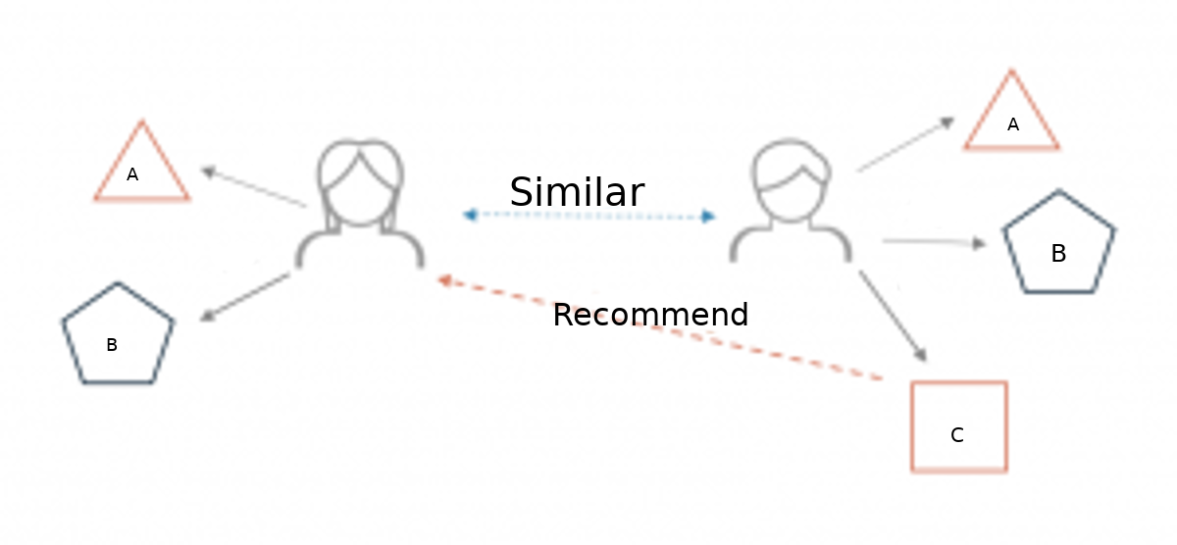

# Description:

## Different types of recommendation engines

The most common types of recommendation systems are **content-based** and **collaborative filtering** recommender systems. In **collaborative filtering**, the behavior of a group of users is used to make recommendations to other users. The recommendation is based on the preference of other users. A simple example would be recommending a movie to a user based on the fact that their friend liked the movie. There are two types of collaborative models **Memory-based** methods and **Model-based**methods. The advantage of memory-based techniques is that they are simple to implement and the resulting recommendations are often easy to explain.

They are divided into two:

### User-based collaborative filtering:

In this model, products are recommended to a user based on the fact that the products have been liked by users similar to the user. For example, if Derrick and Dennis like the same movies and a new movie come out that Derick like, then we can recommend that movie to Dennis because Derrick and Dennis seem to like the same movies.

### Item-based collaborative filtering:

These systems identify similar items based on users’ previous ratings. For example, if users A, B, and C gave a 5-star rating to books X and Y then when a user D buys book Y they also get a recommendation to purchase book X because the system identifies book X and Y as similar based on the ratings of users A, B, and C.

### Model-based methods:

They are based on Matrix Factorization and are better at dealing with sparsity. They are developed using data mining, machine learning algorithms to predict users’ rating of unrated items. In this approach techniques such as dimensionality reduction are used to improve accuracy. Examples of such model-based methods include Decision trees, Rule-based Model, Bayesian Model, and latent factor models.

### Content-based systems:

They use metadata such as genre, producer, actor, musician to recommend items say movies or music. Such a recommendation would be for instance recommending Infinity War that featured Vin Diesel because someone watched and liked The Fate of the Furious. Similarly, you can get music recommendations from certain artists because you liked their music. Content-based systems are based on the idea that if you liked a certain item, you are most likely to like something that is similar to it.

# Datasets to use for building recommender systems:

Here, we have used the Movie Lens Dataset. The data sets were collected over various periods of time, depending on the size of the set.

# Project Features:

Recommend Content Similar to user preferences. Using a recommendation system can draw more visitors to your site or application effectively. You might have observed that eCommerce platforms like Amazon offer product recommendations that you have searched for somewhere on the internet. When you open your Facebook or Instagram, you see similar products. This movie recommendation system will help you get you desired movie and the biggest selling point is that it is going to give you recommendation based on your previous watched movie or search preferences. Competition is high across all domains, whether it’s eCommerce or entertainment. And to stand out, you must cover extra miles. If you offer something that your target customer is looking for but don’t have the measures to guide them to your shop or recommend your offerings, you leave a lot of cash on the table.

# Language:

Python language has been used in making of this movie recommendation system. All libraries and all external Data Sets have been implemented into python code for building this movie recommendation system.

# Walkthrough of code and outputs:

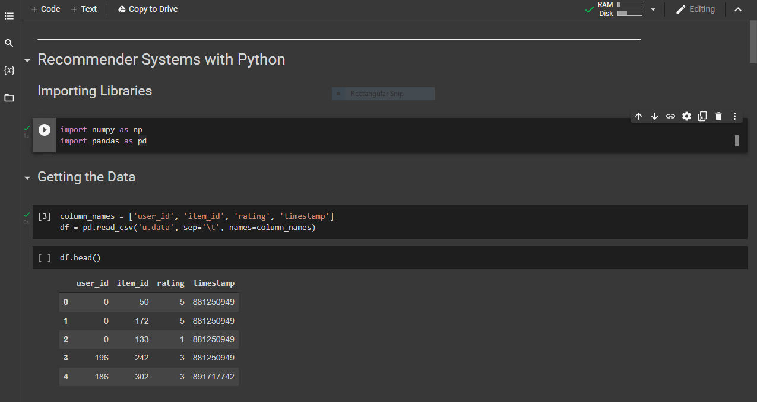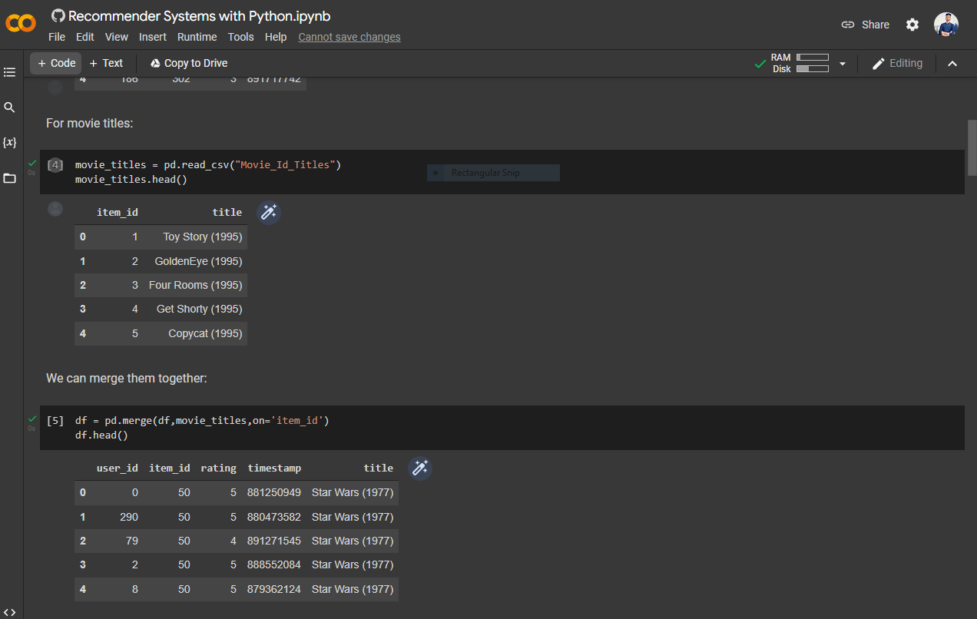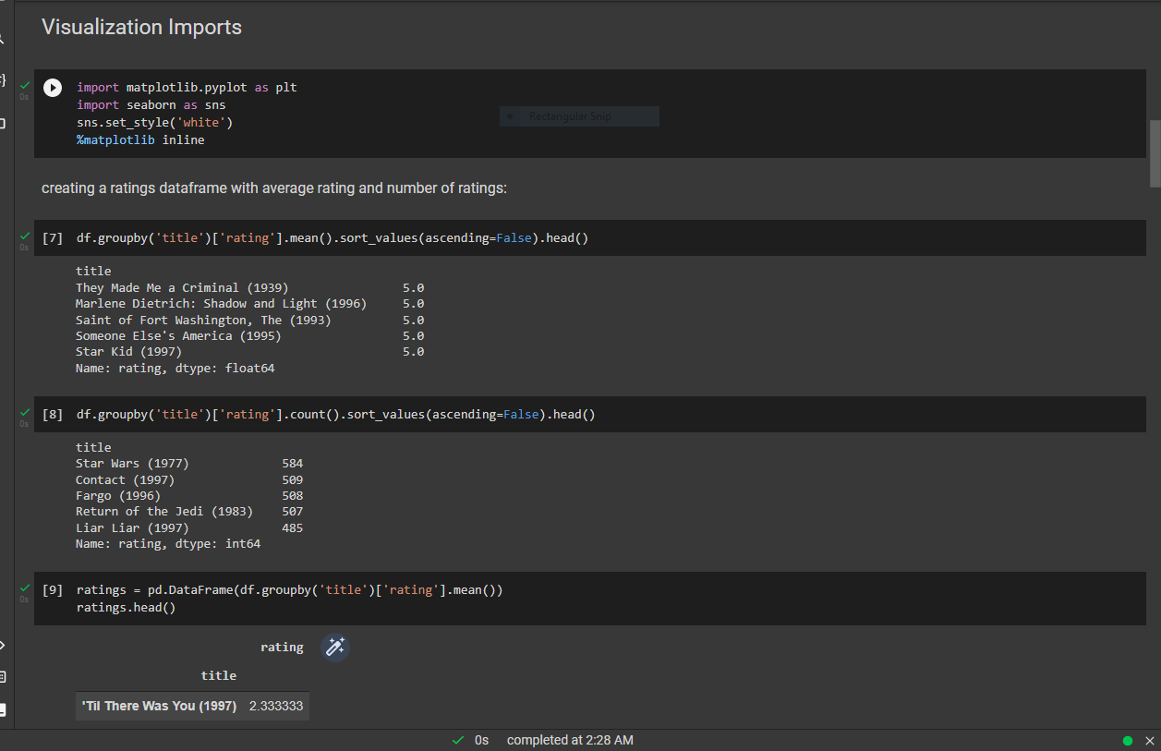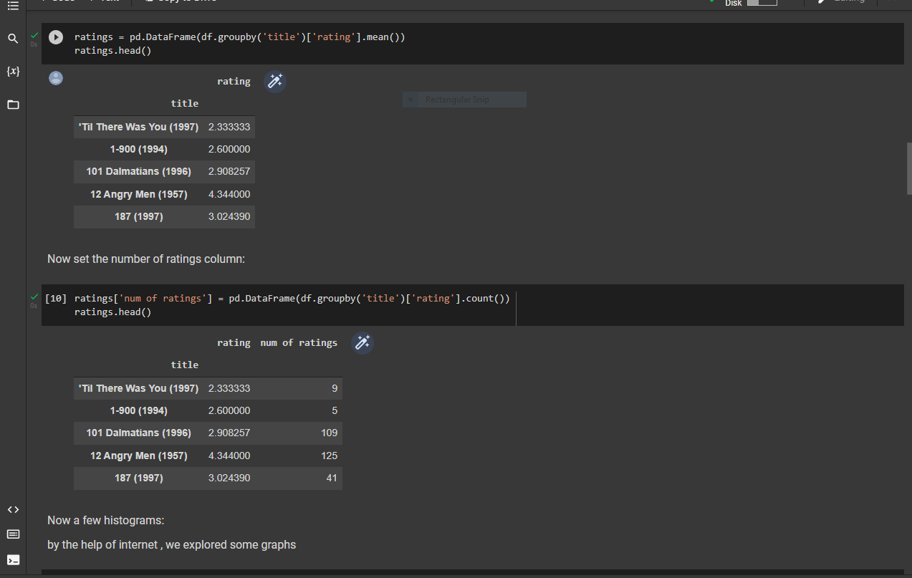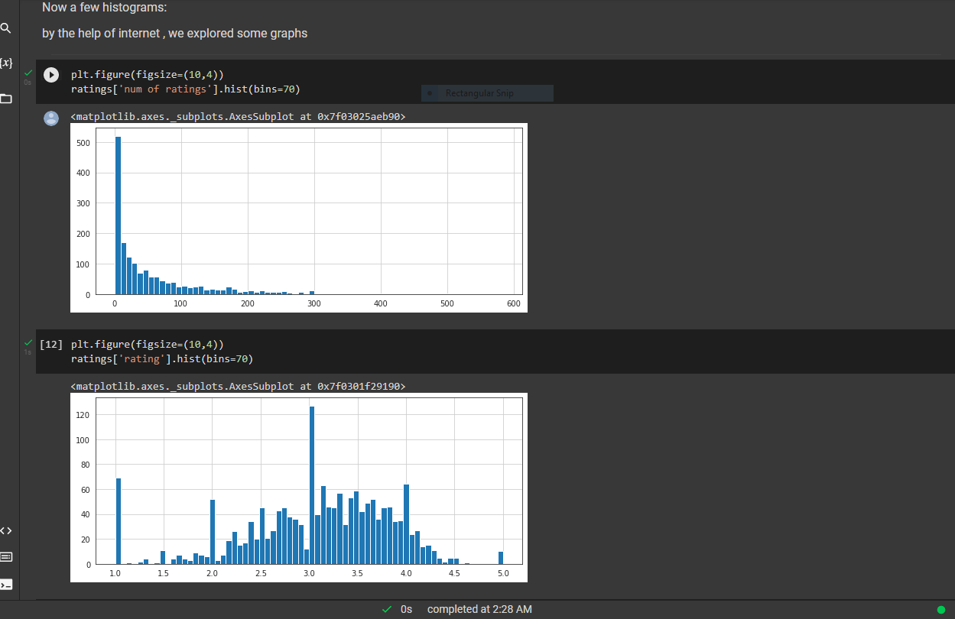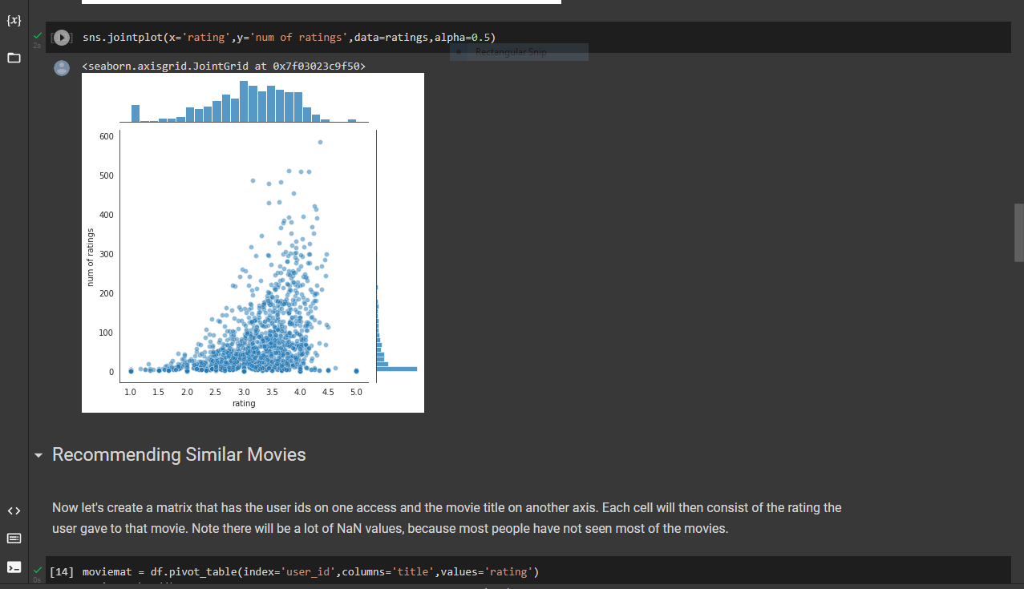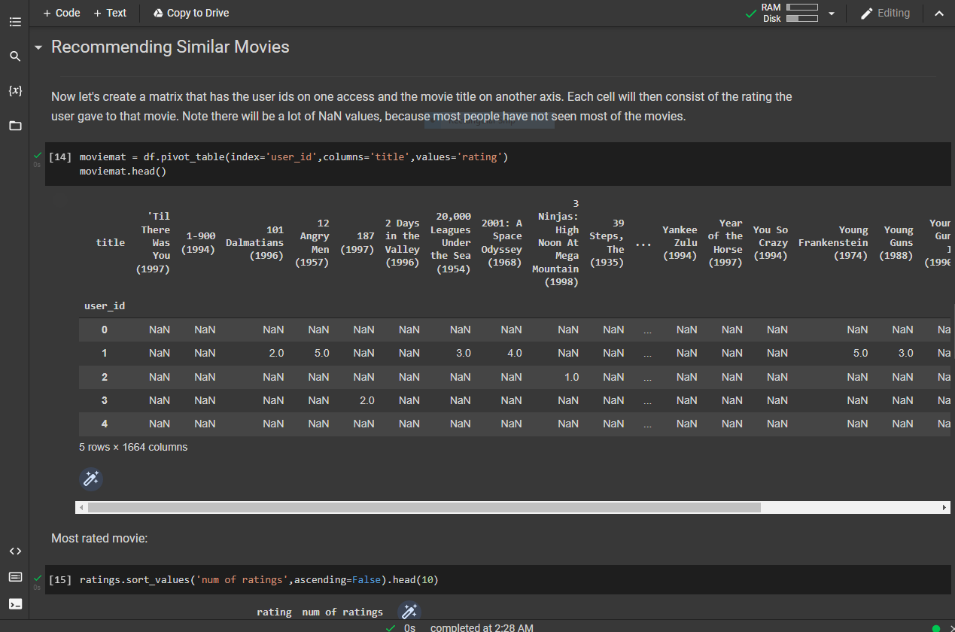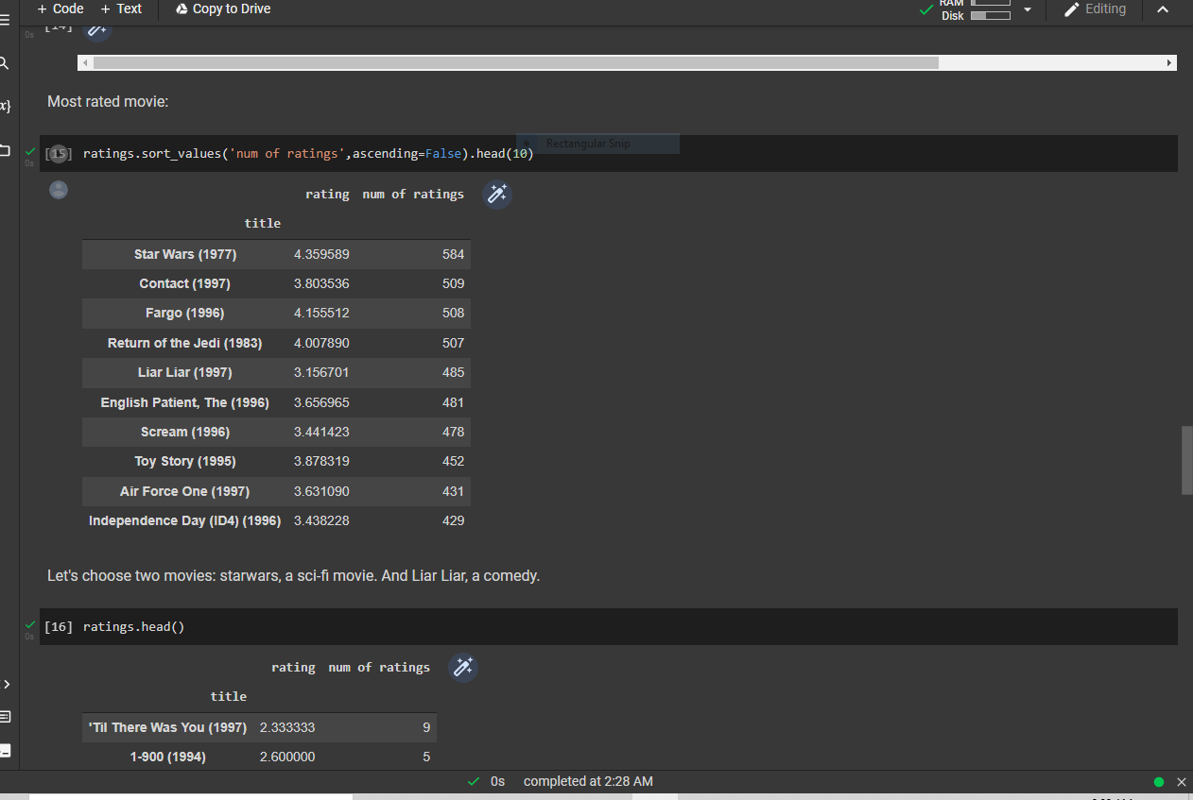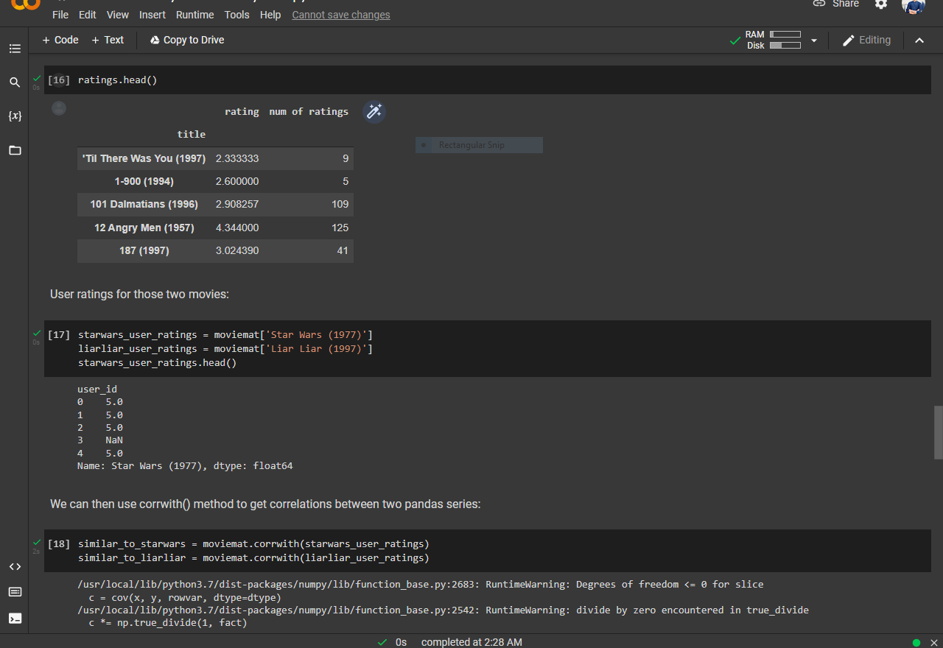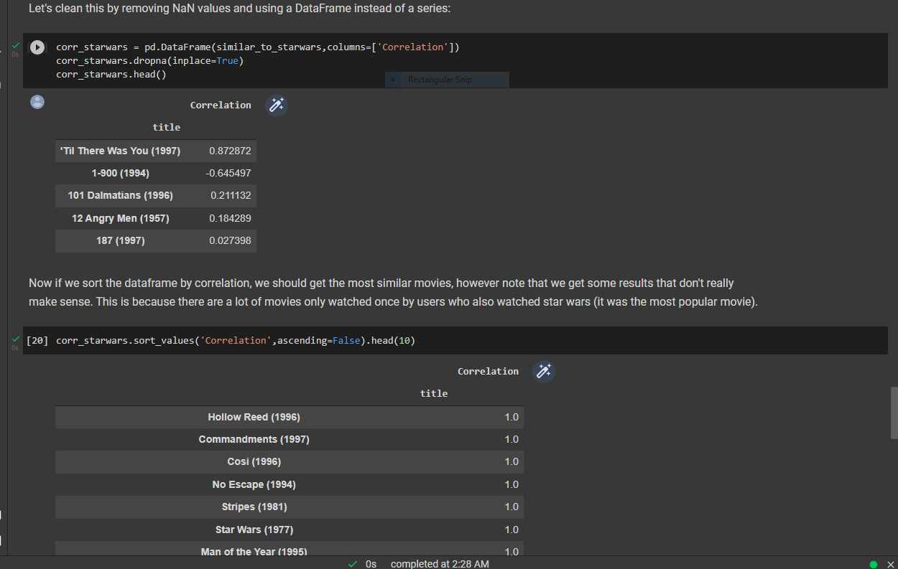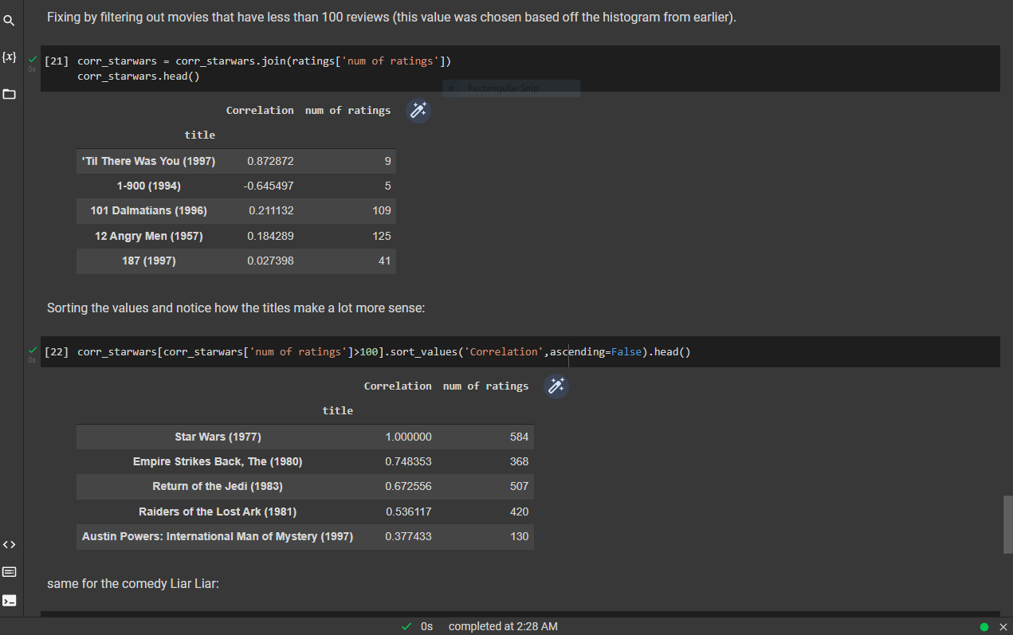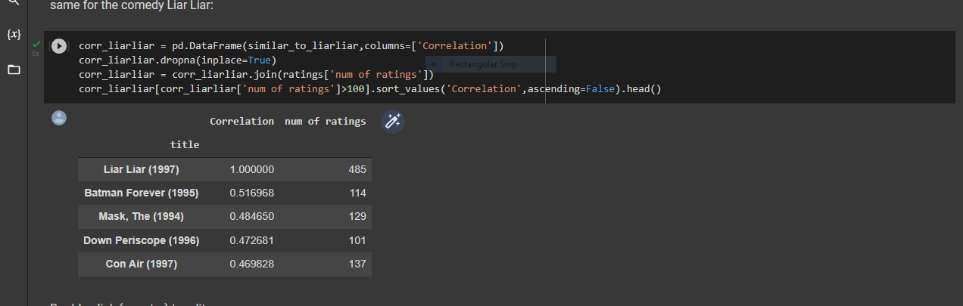

The End!

Thank You.